MyReceipt Android App Assignment Report

Hoonmin Lee

* **My Git repository**

<https://github.com/usc-LH065/myreceipts>

git command:

git clone <https://github.com/usc-LH065/myreceipts.git>

* **MVC diagrams for List UI and Item UI**

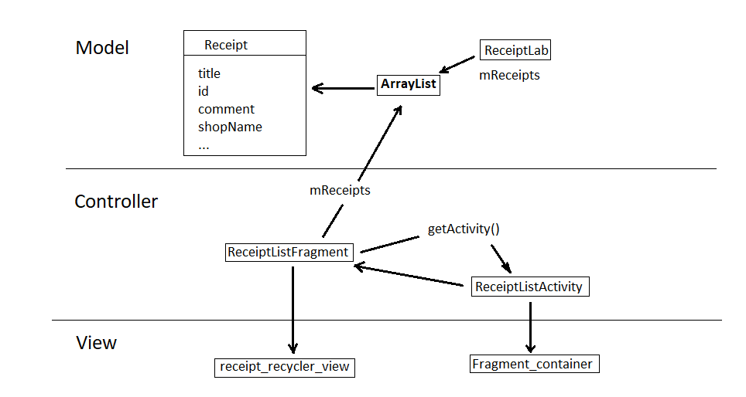

Figure 1. MVC for List UI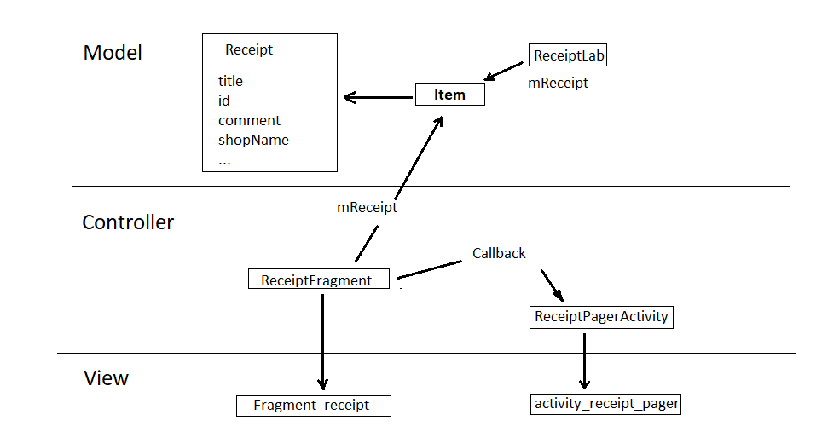

Figure 2. MVC for Item UI

* **Database Schema Design**

|  |  |
| --- | --- |
| Type | Col Name |
| INTEGER | _id |
| INTEGER | uuid |
| TEXT | title |
| INTEGER | date |
| TEXT | shopname |
| DOUBLE | lat |
| DOUBLE | lon |
| TEXT | comment |

Table 1. Database Schema

* **Reflections**

When I setup the Model of this app, I was not sure what parameters should be presented on this model.

In especially, to present the GPS location of each receipt, it was very new to me.   
After googling, I had found the latitude and longitude parameters that shows the GPS location of each item.

And I had found the data type of them can be set into ‘double’.

The most challenge of this project is Task 3 a.

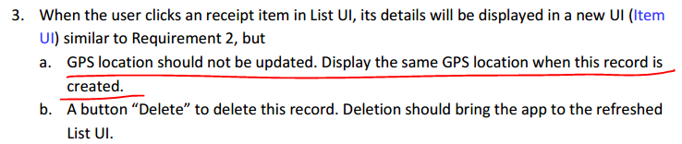

Figure 3. Task 3 a)

I thought a lot for completion of this challenge.   
How can this value be not changed after the record is created.  
To solve this challenge, I set the ‘lat’ and ‘lon’ with initial value of 1000. (because, these real values can’t be greater than 180)

So I can recognize whether these values are set or not.  
If these are 1000, yet it is not initialized with real GPS location data.  
If these are less than 100, it is already initialized with real GPS location data. It was wonderful solution for Task 3 a.

While use GSP data, I have learnt how to use Service in Android.

Next problem, was that should show the map using this GPS data.

How to implement google map on android.

By googling I searched that Android studio supports the default google map activity. It was helpful to me.

And I have learnt how to use Google Map API key and how to get it.

During this project, I also have learnt how to use WebView in Android system.  
Task 4 asks me to implement WebView to show help page.  
This is great experience for me to get something about WebView.

While coding, I have got some fatal errors by my fault. It affected the developing times, and sometimes made me upset.

For using the ‘recyclerView’, I should insert the next code into build.gradle.

implementation 'com.android.support:recyclerview-v7:28.0.0-rc01'

but I have got some conflict on gradle. Because I already used next code and it was not matched to above.

implementation 'com.android.support:appcompat-v7:28.0.0-rc02'

For solve it, I changed the recyclerview implementation version as follow.

implementation 'com.android.support:recyclerview-v7:28.0.0-rc02'

it worked well.

The biggest issue during the developing, was where fragment should be imported.

At first, I imported the Fragment from ‘android.app.fragment’.  
Owing to this, I got unknown errors for using fragments, and consumed lots of time to solve it.  
Finally, I got it was fault by package issue. I changed it as follow.

import android.support.v4.app.Fragment;

it was a good experience about package.

I had some minor issues for save data on item page.

I inserted ‘comment’ for receipt. Go back to list page. Again jump into each item page. Not saved ‘comment’. It was empty. What did I miss?

I found I forgot to update ‘mReceipt’ as soon as I changed data.

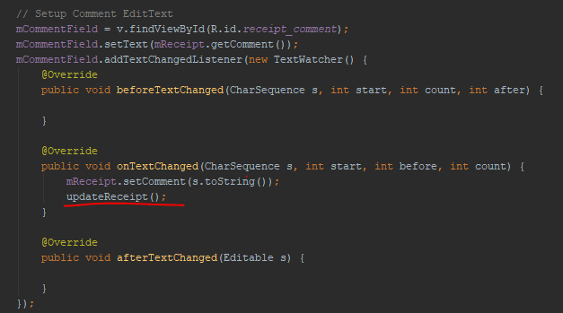

Figure 4. missed code for updating receipt

From this project, I have lots of experience to design workflow of app, code, debug, run and get final ‘apk’ file.